

Cannon Building | STATE OF DELAWARE | Telephone: (302) 744-4500
861 Silver Lake Blvd., Suite 203 | DEPARTMENT OF STATE | Fax: (302) 739-2711
Dover, Delaware 19904-2467 |  | Website: www.dpr.delaware.gov
 | DIVISION OF PROFESSIONAL REGULATION

PUBLIC MEETING MINUTES: Board of Occupational Therapy Practice

MEETING DATE AND TIME: Monday March 27, 2006 at 4:30 p.m.

PLACE: 861 Silver Lake Boulevard, Dover, Delaware
Conference Room B, second floor of the Cannon Building

MINUTES APPROVED: Approved 04/19/06

MEMBERS PRESENT

December Hughes, Vice-President
Michele Maahs, Public Member
Virginia Mirro, Public Member
DIVISION STAFF/DEPUTY ATTORNEY GENERAL PRESENT
Abby Adams, Deputy Attorney General
Gayle Melvin, Administrative Specialist III
Katie Rochester, Administrative Specialist II

MEMBERS ABSENT
Mike von Reider, President, Public Member
Debra Young, Professional Member, Secretary

ALSO PRESENT
Karin B. Parsons, COTA
Margaret Heyd, OT
Penny Shultie, COTA
Melody Persolio, COTA
Camilla Harrod, OT
Christina Cutts, OT

CALL TO ORDER

Ms. Hughes called the meeting to order at 4:30 p.m.

REVIEW OF MINUTES

The Board reviewed the minutes of the February 8, 2006, meeting. Ms. Hughes made a motion, seconded by Ms. Maahs to approve the minutes as presented. The motion was unanimously carried.

UNFINISHED BUSINESS

Review of Proposed Rules and Regulations Regarding On-line Renewals

There was no further review of the proposed rules and regulations regarding on-line renewals. The Public Hearing has been scheduled for March 15, 2006 at 4:30 p.m.

NEW BUSINESS

Review of Occupational Therapist/Occupational Therapy Assistant Applications

Ms. Hughes made a motion, seconded by Ms. Mirro to approve applications for the following persons:

Margaret A. Heyd - Occupational Therapist
David K. Perry –Occupational Therapist
Vivian K. Ramsay –Occupational Therapy Assistant
Mary Kate Stich – Occupational Therapist
Elaine M. Ulmer – Occupational Therapy Assistant

The motion was unanimously carried.

The application of Terrie A. Roney for an occupational therapist license was reviewed. The Board decided to table this application for further review by Ms. Adams.

Review of Continuing Education Activities

The following courses and hours were motioned for approval by Ms. Hughes and seconded by Ms. Mirro for the following courses:
Drexel University
Certificate of the Hand & Upper Quarter Rehabilitation – 19 hours
Bridget Cassidy and Kathleen Nutley
Philadelphia Regional Fieldwork & Austill’s Rehab Services, Inc.
Putting Occupation into Fieldwork Education – 5 hours, 10 minutes
National Academy for Continuing Education
Documentation and Functional Outcomes – 30 hours – Denied
Industrial Medicine and Rehabilitation – 10 hours
Lumbar Spine Injuries in Athletics – 10 hours
Total Knee Replacement – 10 hours
Biomechanical & Sensory Strategies for Improving Motor Control in Children with Neuromotor Deficits – 9.5 hours
Future Horizons
Asperger’s & High-Functioning Autism Conference – 6 hours
Ergo Rehab
Certified Specialist in Functional Assessment – 10 hours
Enrichment Audio Resource Services, Inc.
Understanding Vision Loss and Its Impact on Treatment Strategies – 7 hours

Ms. Hughes made a motion, seconded by Ms. Mirro to approve applications for the following persons:

The ROHO Group
Clinical & Material Considerations for Wheelchair Seating Surfaces – 1 hour
Hand Rehabilitation Foundation
First Combined Meeting of the Curtis National Hand Center,
Hospital for Special Surgery, and Jefferson Hand Club Hand Surgery Training Programs – 6.5 hours
Integrative Therapy Services; Lake Forest School District
Classroom Strategies for Fine Motor Skills Development – 1.5 hours
National Academy for Continuing Education
Upper Extremity – Evaluation & Treatment of Non-surgical Orthopedic Problems – 10 hours
Lower Kinetic Chain and the Foot & Ankle – 10 hours
Strategies for Managed Care in Rehabilitation – 10 hours
The Female Athlete – 10 hours
Clinician’s View
Occupational Therapy Programs/ COLLAGE
Connections that Click – Tips for Stimulating Social Skills – 4 ¾ hours
Integrated Health Seminars
New Risk Factors for Cardiovascular Disease – 7 hours
Institute for Natural Resources
“His Brain, Her Brain” – 6 hours
The addicted Brain – 6 hours

The following courses was tabled:
Bridget Cassidy and Kathleen Nutley
Nurses ‘n Kids, Inc. Understanding a Premature Infant’s Signals – 1 Hour – Tabled
Rehabilitation and Long term Care – 15 hours – Tabled

The motion was unanimously carried.

Other Business Before the Board (for discussion only)

Ms. Hughes posed the question to the DAG and to the Board as to whether they wanted to and are able to revise the rules and regulations to state that the Board should appoint the Administrative Specialist to approve applications only in the event that the board does not have a quorum to meet. Ms. Hughes said that she felt that this might be necessary in light of the fact that there are only 5 board members. Ms. Adams said the she would research this and provide some information concerning this issue at the next meeting. There may be a section in Freedom of Information Act that would allow this appointment.

Public Comment

Ms. Margaret Heyd echoed what Ms. Hughes stated about providing emergency backup for approval of applications should it be necessary. She stated that she was held from starting a job due to the fact that the Board did not meet on its scheduled date of March 15, 2006.

Next Scheduled Meeting

The next meeting will be held on April 19, 2006 at 4:30 p.m. in Conference Room A, second floor of the Cannon Building, 861 Silver Lake Boulevard, Dover, Delaware.

Adjournment

There being no further business, Ms. Hughes made a motion, seconded by Ms. Maahs to adjourn the meeting. The motion was unanimously carried. The meeting adjourned at 5:50 p.m.

Respectfully submitted,

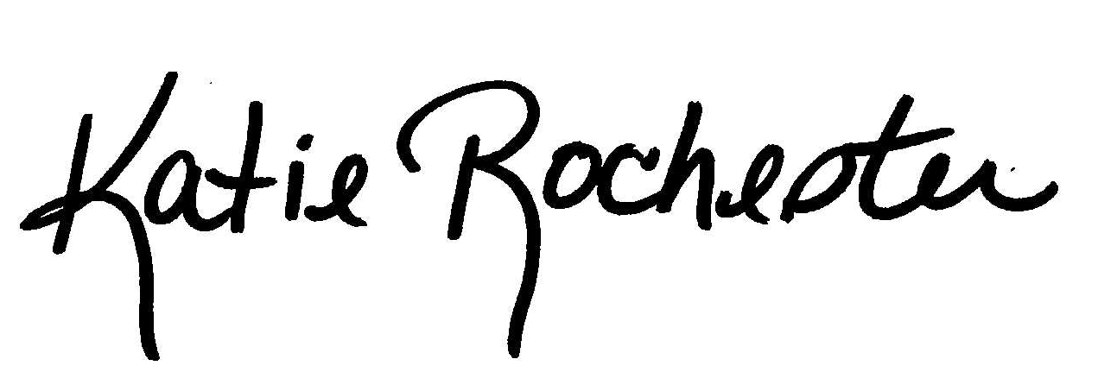
Katie Rochester
Administrative Specialist II

