
Cannon Building | STATE OF DELAWARE | Telephone: (302) 744-4500
861 Silver Lake Blvd., Suite 203 | DEPARTMENT OF STATE | Fax: (302) 739-2711
Dover, Delaware 19904-2467 |  | Website: www.dpr.delaware.gov
 | DIVISION OF PROFESSIONAL REGULATION

PUBLIC MEETING MINUTES: Board of Geology

MEETING DATE AND TIME: Friday, September 7, 2007 at 10:00 a.m.

PLACE: 861 Silver Lake Boulevard, Dover, Delaware
Conference Room B, Cannon Building

MINUTES APPROVED: October 5, 2007

MEMBERS PRESENT
Steven M. Smailer, Professional Member, President
William Schenck, Professional Member, Vice President
Amos Aiken, Public Member
Kim McKenna, Professional Member, Secretary

DIVISION STAFF/D.A.G/COURT REPORTER PRESENT
Allison Reardon, Deputy Attorney General
Nancy Fields, Administrative Specialist

MEMBERS ABSENT
Dana Long, Public Member
Stephen Williams, Professional Member

CALL TO ORDER
Mr. Smailer called the meeting to order at 10:08 a.m.
REVIEW OF MINUTES
The Board reviewed the minutes from the August 3, 2007 meeting. Ms. McKenna advised Ms. Fields of a typographical error and made a motion to approve the minutes as amended. The motion was seconded by Mr. Smailer and carried unanimously.

OLD BUSINESS

Discuss ASBOG Annual Meeting

The Board decided to table this until the next Board meeting as intended at the August meeting.

NEW BUSINESS
Review of Application for Licensure through Reciprocity

Mr. Smailer reviewed Mr. Ethan Weikel’s application for licensure through the State of California. Mr. Weikel received his CA license on June 2, 2006: therefore, he does not meet the reciprocity requirement of having two years of work experience after licensure. Because he has over 5 years total experience in the field, he can apply as a new applicant by sending in 3 more professional references and a letter stating that he wants to change his application to new licensure to the Board. Mr. Smailer made a motion to table his application and to send him a letter stating the above. The motion was seconded by Mr. Schenck and carried unanimously.

Elections

The current slate of officers was nominated by Mr. Aiken and seconded by Ms. McKenna for the second term. The motion carried unanimously.

Discuss 2008 Calendar

The Board decided to keep the first Friday of each month as the Board meeting days for the 2008 calendar year, with the exception of January and July.

OTHER BUSINESS
Ms. Reardon, the Deputy Attorney General, suggested that we add the Strategic Planning onto the agenda for the October meeting.

Ms. Reardon also reminded the Board and Ms. Fields that all applications that the Board proposed to deny have to be brought back to the Board for final action; therefore, we have to put the ones that were denied last month on the agenda for next month.

The Board would like to be able to send two members of the Board to the ASBOG Conference in the Fall and still continue to have one member go to the ASBOG Spring Conference; therefore, Mr. Schenck made a motion that Mr. Smailer will write a letter to ask the Director of the Division, James Collins for additional funds in their budget for travel for an additional member because they feel the conferences are important. The motion was seconded by Ms. McKenna and carried unanimously.

Ms. Fields informed the Board that due to the Division of Professional Regulation restructuring into teams in October that the Board of Geology will now have another Administrative Specialist.

PUBLIC COMMENT
There were no public comments at this meeting.

NEXT SCHEDULED MEETING
The next meeting is scheduled for October 5, 2007 at 10:00 am in Conference Room B, second floor of the Cannon Building, 861 Silver Lake Boulevard, Dover, Delaware.

ADJOURNMENT
There being no further business, Mr. Schenck made a motion to adjourn the meeting, which was seconded by Mr. Aiken. The motion was unanimously carried. The meeting adjourned at 10:38 a.m.

Respectfully submitted,

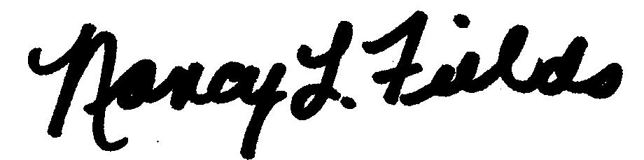
Nancy Fields
Administrative Specialist II

