Charles Stevenson
LEPC
(302) 855-7810 Office
(302) 855-7805 Fax
(302) 855-7803 Office After Hours
(302) 855-7800 Fax After Hours
EMERGENCY OPERATIONS CENTER
21911 RUDDER LANE
P.O. BOX 589
GEORGETOWN, DE 19947
Sussex County

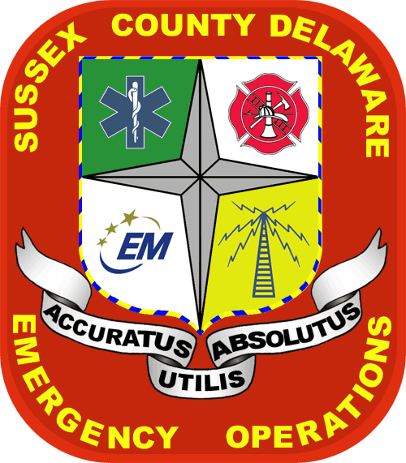

SUSSEX COUNTY
LOCAL EMERGENCY PLANNING COMMITTEE
MEETING
THURSDAY, January 10, 2013
10:00 A.M.
SUSSEX COUNTY
EMERGENCY OPERATION CENTER
21911 RUDDER LANE
GEORGETOWN, DE

AGENDA
- Call meeting to order
- Approval of minutes from last meeting
- Introductions
- Updates on current issues
  - Tier II Manager – Kris Gontovsky
  - Incident Reports, DECON- Eric Huovinen
  - DEMA Updates –Kevin Kille
    - HMEP Funds
    - SERC Meeting
    - HazMat Training Workshop
  - Decon trailer updates-Dave Mick/Eric Huovinen
  - New Castle LEPC Updates-Dave Irwin
  - City Of Wilmington LEPC Updates-George Giles
  - Kent County LEPC Updates-Dave Mick
h. Sussex LEPC Chairman Updates
- Facility visits
- Drills/Exercise
- New business
Presentation-Matt Higgins, DNREC-ERB, will provide a presentation on the recent train derailment in Bridgeville.

NEXT MEETING- Thursday, March 14, 2013 – Sussex EOC, Georgetown

