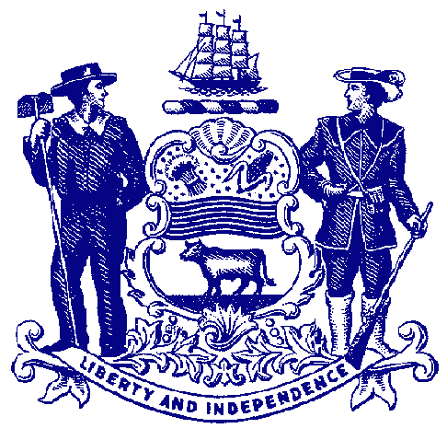



**Council on Greenways & Trails**

**Wednesday, May 1, 2013**

**9:30 am to 12:00**

**Location: Buena Vista Conference Center**

**http://buenavista.delaware.gov/**

**661 S. DuPont Hwy**

**New Castle, DE 19720**

**Agenda**

**Welcome & Introductions**

**Approval of January 30, 2013 Meeting Minutes**

**Recreational Trail Users Update**

Hiking – Wendel Cassel

Equestrian – Mary Everhart

Mountain Biking – Jim Ireland

**Trail & Pathway Initiative Project Summary**

DelDOT Projects – Marco Boyce

Buena Vista – Ken Darsney & Lynn Riley (followup by an outdoor review of trails)

**National Recreation Trail Nominations** – Avery Dunn

**American Trails Awards** – David Bartoo

**Announcements**

Upcoming Events

2013 Meeting Dates – September 18, December 11

National Trails Day – June 1

**Adjourn**