Charles Stevenson
LEPC
(302) 855-7810 Office
(302) 855-7805 Fax
(302) 855-7803 Office After Hours
(302) 855-7800 Fax After Hours
EMERGENCY OPERATIONS CENTER
21911 RUDDER LANE
P.O. BOX 589
GEORGETOWN, DE 19947
Sussex County

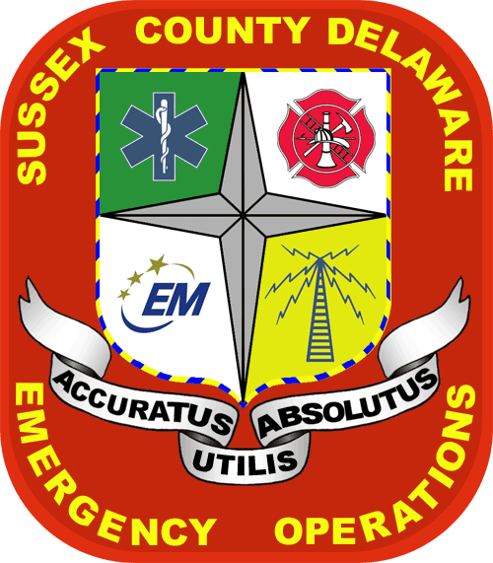

SUSSEX COUNTY
LOCAL EMERGENCY PLANNING COMMITTEE
MEETING
THURSDAY, March 14, 2013
10:00 A.M.
SUSSEX COUNTY
EMERGENCY OPERATION CENTER
21911 RUDDER LANE
GEORGETOWN, DE

AGENDA
- Call meeting to order
- Approval of minutes from last meeting
- Introductions
- Updates on current issues
  - Tier II Manager – Kris Gontovsky
  - DEMA Updates –Kevin Kille
    - HMEP Funds
    - SERC Meeting
  - Incident Reports, DECON- Eric Huovinen
  - Decon trailer updates-Dave Mick/Eric Huovinen
  - Kent County LEPC Updates-Dave Mick
  - HazMat Training Workshop-Dave Irwin
  - New Castle LEPC Updates-Dave Irwin
  - City Of Wilmington LEPC Updates-George Giles
  - Kent County LEPC Updates-Dave Mick
h. Sussex LEPC Chairman Updates
- Facility visits
- Drills/Exercise
- New business
Presentation to Be determined

NEXT MEETING- Thursday May 9, 2013 – Sussex EOC, Georgetown

In accordance with 29 Del. C. §10004(e)(2), this Agenda was posted on 3/7/13, at 9:30 a.m., and at least seven (7) days in advance of the meeting.
This Agenda is subject to change to include the addition or deletion of items, including Executive Sessions, which arise at the time of the Meeting.
Agenda items listed may be considered out of sequence.

