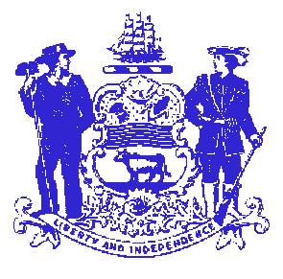

Telephone: (302) 577-5030
Fax: (302) 577-3440
STATE OF DELAWARE

EXECUTIVE DEPARTMENT
CRIMINAL JUSTICE COUNCIL
STATE OFFICE BUILDING – 10th FLOOR
820 FRENCH STREET
WILMINGTON, DELAWARE 19801

Violence Against Women Act Implementation Committee
April 24, 2013
2:00PM-4:00PM

Supreme Court Conference Room
11th Floor -Carvel State Office Building
820 N. French St.
Wilmington, DE 19801

- Approval of the minutes from the November 26, 2012 meeting

- CJC Subcommittees and VAWA Implementation Committee Vacancy

- FFY2012 SASP Formula Grant planning

- Update federal activity
- Sequestration
- VAWA Reauthorization

- New Three Year Implementation Plan

- Federal Grant Update:
- SASP Formula Grant Update:
  - FY2010 ($153,573): End date 7/31/12 (closeout pending OVW approval)
  - FY2011 ($153,458): End date 7/31/13(funds obligated)
  - FY2012 ($233.227): End date 7/31/14

- STOP Formula Grant Update
  - FY 2009 ($856,468): End date 12/31/12 (close out pending OVW approval)
  - FY2010 ($890,952): End date 7/30/13 (9-month extension request pending OVW)
    - Balance in Law Enforcement
  - FY2011 ($893,875): End date 6/30/13
    - Unobligated balance
  - FY2012 ($887,639): 6/30/2014 End date

- Draft solicitations
    - for FFY2011 balances

- New Business
    - High Risk DV Team
    - Domestic Violence Fund

- Other/Public Comment

Future Meeting Dates
None scheduled

