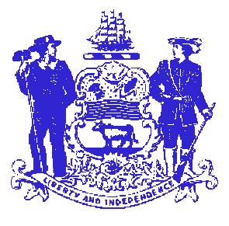

Telephone: (302) 577-5030
Fax: (302) 577-3440
STATE OF DELAWARE

EXECUTIVE DEPARTMENT
CRIMINAL JUSTICE COUNCIL
STATE OFFICE BUILDING – 10th FLOOR
820 FRENCH STREET
WILMINGTON, DELAWARE 19801

FFY2012 Sexual Assault Services Program (SASP)
June 12, 2013
10:00AM
Delaware State Police Museum
1425 North DuPont Highway
Dover, DE 19903

- Description of the Sexual Assault Services Program (SASP)
- Presentation on the FFY2012 SASP Plan and Proposed Services
    - CJC
    - Children’s Advocacy Center, Inc
    - ContactLifeline. Inc
- Discussion on enhancing outreach efforts to the underserved communities
    - Special emphasis on culturally specific services, outreach to immigrant communities, non-English speaking individuals, and/or victims with disabilities
- Other/Public Comment

