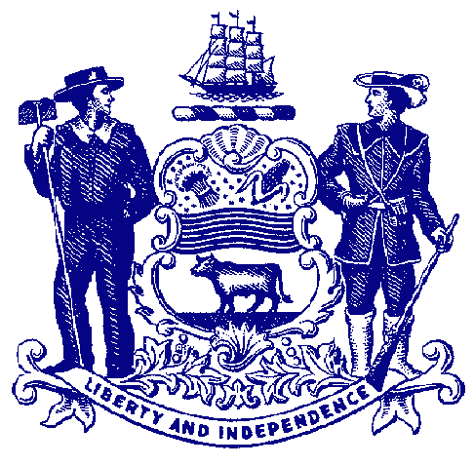



**Council on Greenways & Trails**

**Wednesday, September 18, 2013**

**9:30 am to 12:00**

Location: Dover Public Library (directions below)

35 E Loockerman Street

Dover, DE 19901

**Agenda**

**Welcome & Introductions**

**Approval of May 1, 2013 Meeting Minutes**

**Trail & Pathway Initiative Project Summary**

Bayshore Initiative – Karen Bennett, DNREC BayshoreManager

Dover Bicycle & Pedestrian Initiatives – Ann Marie Townshend, Dover Planning Director

Pathway & Trail Project updates – DNREC & DelDOT

**Recreational Trail Users Update**

Hiking – Wendel Cassel

Equestrian – Mary Everhart

Mountain Biking – Jim Ireland

**Announcements**

Future Trail Plans

Upcoming Events

Council meeting – December 11, location TBD

C&D Canal Trail dedication - TBD

Hike Across Delaware – November 2, 2013

National Trails Day – June 7, 2014

**Adjourn**

**Immediately following the meeting we will lead a short walk to review the Capital City Trail.**

**Library Directions from Rt 13 –** drive west on E. Loockerman; continue through Innovation Way/Legislative Ave intersection; enter parking lot via a shared library & Post Office entrance. Library is on the left. Park adjoining side and rear of library. Building entrances on Loockerman or from back parking lot.