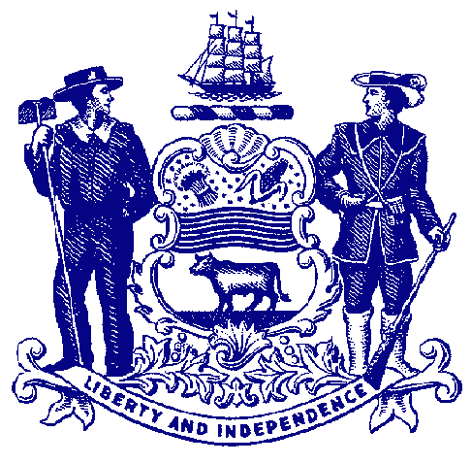



**Council on Greenways & Trails**

**Friday, February 7, 2014**

**9:30 am to 12:00**

Location: DelDOT, Farmington Conference Room

800 Bay Road Dover, DE 19901

**Proposed Agenda**

**Welcome & Introductions**

**Approval of May 1 and September 18, 2013 Meeting Minutes**

**Trail Updates –** Staff

**Trail Grants Application –** Bob Ehemann

**Volunteer Program -** Glen Stubbolo, Chief, Volunteer Programs

**Healthy Community Recognition –** Kendall Sommers

**Recreational Trail Users Update**

Hiking – Wendel Cassel

Equestrian – Mary Everhart

Mountain Biking – Jim Ireland

**Announcements**

DNREC Budget Hearing – February 12, 2014, 2:15, JFC Hearing Room

DNREC Bond Bill Hearing – March 6, 2014, 10:00, JFC Hearing Room

Heels & Wheels Summit – March 21, 2014, Clayton Hall, UD

National Trails Day – June 7, 2014

**Adjourn**