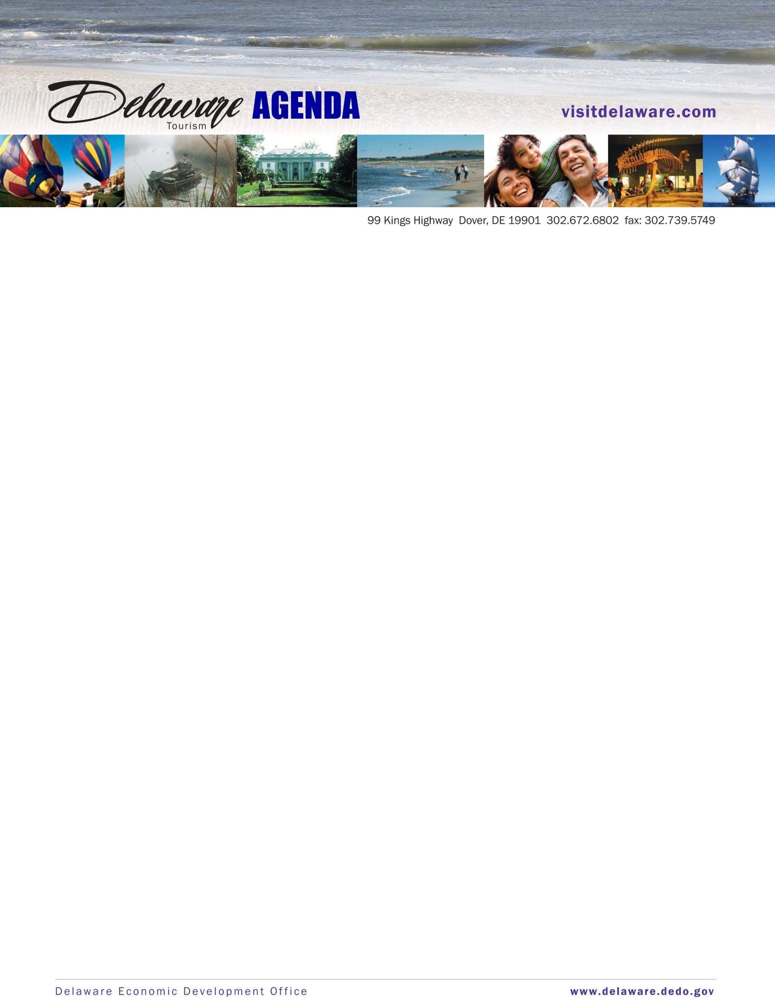

Tourism Advisory Board Meeting
Tuesday, November 19, 2013 (9:30 a.m. – 11:30 a.m.)
Large Conference Room
Dover, Delaware

AGENDA

- Call Meeting to Order George Fiorile

- Review Meeting Minutes All

- Delaware Tourism Office 1st, 2nd & 3rd Quarter Report Linda Parkowski

- PAT Quarterly Report All

- DTO Budget Linda Parkowski

- New Business All

- Public Comment

- Adjourn

