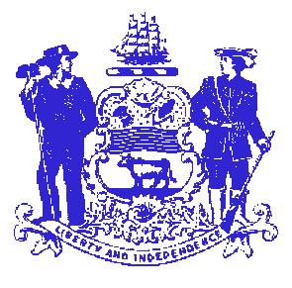

Telephone: (302) 577-5030
Fax: (302) 577-3440
STATE OF DELAWARE
EXECUTIVE DEPARTMENT
CRIMINAL JUSTICE COUNCIL
STATE OFFICE BUILDING – 10th FLOOR
820 FRENCH STREET
WILMINGTON, DELAWARE 19801

CRIMINAL JUSTICE COUNCIL MEETING AGENDA
Monday, May 19, 2014 - 2:30 p.m.
DE State Police Troop 2 - 100 LaGrange Road - Newark (Route 40)

Attachment
1. Approval of April 21, 2014 meeting minutes 1

2. Federal Funding
A. FY2013 Coverdell Forensic Science Improvement Grant 2
($58,186) - Valarie Tickle

B. FY2013 Byrne Justice Assistance Grant ($501,079) 3
Charles Pugh

3. Legislative Committee Report (handout at meeting)

4. The Council may vote to meet in executive session to discuss
Executive Director position

5. Statistical Analysis Center Report

6. Criminal Justice Council Staff Report

7. New Business

