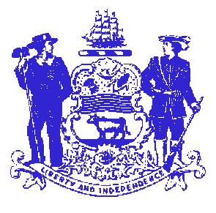

Telephone: (302) 577-5030
Fax: (302) 577-3440
STATE OF DELAWARE

EXECUTIVE DEPARTMENT
CRIMINAL JUSTICE COUNCIL
STATE OFFICE BUILDING – 10th FLOOR
820 FRENCH STREET
WILMINGTON, DELAWARE 19801

Victims Services Advisory Committee
March 27, 2014
2:00PM-3:30PM
The Delaware Economic Development Office (DEDO) - Conference Room
10th Floor -Carvel State Office Building
820 N. French St.
Wilmington, DE 19801

- Welcome and Introductions

- Approval of the minutes from meeting held September 11, 2013

- Family Violence Prevention & Services Formula Grant Program:
    - Update
    - FFY2014 Federal Application submitted

- VOCA-Assistance Formula Grant Program:
    - Update
    - FFY2014 VOCA-Assistance Allocations not announced

- Strategic Planning

- Other/Public Comment

