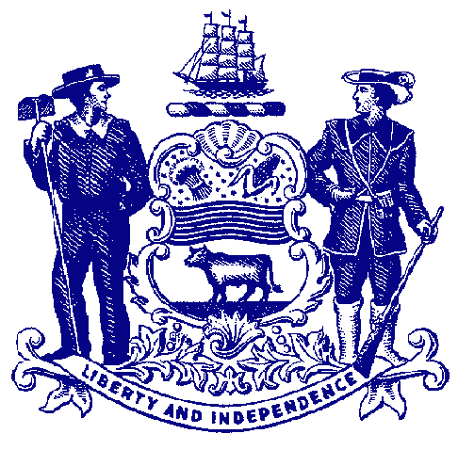



**Council on Greenways & Trails**

September 12, 2014

9:30 am to 12:00

Dover Public Library

**Agenda**

**Welcome & Introductions**

**Approval of April 30, 2014 Meeting Minutes**

**Recreational Trail Users Update**

Hiking – Gary Kirk

Equestrian – Mary Everhart

Mountain Biking – Jim Ireland

**Trail & Pathway Initiative Priority Projects** – Staff

Auburn Heights

Assawoman Canal

Swinging Bridge, Brandywine Park

Brandywine Creek SP, Rocky Run Bridge

White Clay Creek SP, Tri-Valley Trail

Cape Henlopen SP, Georgetown-Lewes-Cape

**DTF Trail Grant Review –** Bob Ehemann

**Delaware Land & Water Conservation Trust Fund –** Ray Bivens, Director

**Brandywine Creek State Park –** David Bartoo

**Announcements & Updates**

Next meeting: December 3, 2014

Bellevue SP – Sept 13 Walk for a Healthy Community Fund Raiser

Planning for Healthy & Sustainable Places – October 28-26, Delaware APA/Nemours

Outdoors Summit – November 17th Stockley Center

**Adjourn**

**Post Meeting – 1 block walk to Capital City Trail, Phase 2**