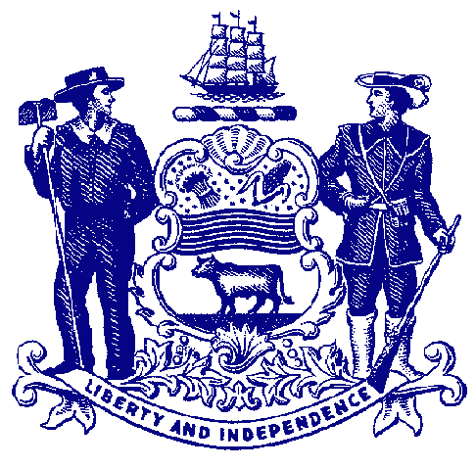



**Council on Greenways & Trails**

December 5, 2014

9:30 am to 12:00

Dover Public Library

**Agenda**

**Welcome & Introductions**

**Approval of September 12, 2014 Meeting Minutes**

**Recreational Trail Users Update**

Hiking – Wendel Cassel

Equestrian – Mary Everhart

Mountain Biking – Jim Ireland

**Walkable-Bikeable Delaware Committee (Council on Health Promotion & Disease Prevention) and Outdoor Summit** – John Hollis, Nemours

**Trail & Pathway Initiative Projects** – Park Resource Office staff

Assawoman Canal

Rocky Run Bridge, Brandywine Creek SP

Tri-Valley Trail, White Clay Creek SP

Georgetown-Lewes-Cape Henlopen Trail

**Trail Crew Accomplishments –** Thomas “Chip” Kneavel, Trail Crew Chief

**2009-2014 activities**

**Trail counters**

**Brandywine Creek State Park Trail Plan -** David Bartoo

Public participation schedule

**Announcements & Updates**

2015 Council meetings – March 4 (Wed) or 6 (Fri); June; September; December

Trail events

Capital City Trail ribbon cutting – Monday, December 15 @ 2pm, on the trail

Assawoman Canal Trail ground breaking – to be determined

**Adjourn**