Department of Elections for Kent County
100 Enterprise Place, Suite 5
Dover, DE 19904
Phone: 739-4498
Fax: 739-4515
http://electionskc.delaware.gov

PUBLIC MEETING

Preparation and scanning of Absentee Ballots
October 31, 2014 from 2:30 – 5:00 p.m. in the Department’s office
100 Enterprise Place, Suite 5, Dover, DE 19904

AGENDA

1. Introductions
2. Overview
3. Administering the oath
4. Preparing the ballots for tabulation
5. Secure the prepared ballots
6. Public Comments
7. Closing Comments

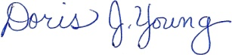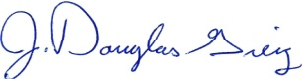
Doris J. Young J. Douglas Greig
Director Deputy Director

This meeting will recess and reconvene as necessary on November 1st at 3:00p.m., November 2rd at 3:00 p.m., and November 4th at 1:00p.m. to prepare and scan.

