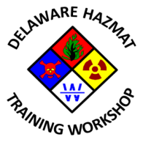

9th Annual State of Delaware Hazardous Materials Training Workshop

Planning Committee Meeting #2
Mill Creek Fire Station 21
Wednesday, September 9, 2015
2:30 PM – 4:30 PM

Agenda

- Call to Order
- Meeting agenda approval
- Previous meeting minutes approval
- 8th Workshop speaker payment update
- Status of Sponsor/Exhibitor September 9th email launch
- Non-paying exhibitors (OSHA, PHMSA, TRANSCAER)
- Review of action items from 08/13/2015 meeting
- Review, refine and approve draft 2016 Program
- Workshop promotional items discussion
- Registration launch date projection
- Any other business
- Next meeting date
- Adjournment

