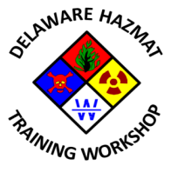

9th Annual State of Delaware Hazardous Materials Training Workshop

Planning Committee Meeting #3
Mill Creek Fire Station 21
Tuesday, October 6, 2015
2:30 PM – 4:30 PM

Agenda

- Call to Order
- Meeting agenda approval
- Previous meeting minutes approval
- Status of Sponsor/Exhibitor survey launch
- Review of action items from 09/09/2015 meeting
- 2016 Program Update
- Agree Keynote speaker and Friday special session topic and presenter
- Workshop promotional item(s) selection and approval
- Distribution list for the “Save the Date” notice
- Any other business
- Next meeting date
- Adjournment

