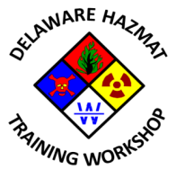

9th Annual State of Delaware Hazardous Materials Training Workshop

Planning Committee Meeting #4
Mill Creek Fire Station 21
Tuesday, November 10, 2015
2:30 PM – 4:30 PM

Agenda

- Call to Order
- Meeting agenda approval
- Previous meeting minutes approval
- Status of Sponsor/Exhibitor survey launch
- Review of action items from 10/06/2015 meeting
- 2016 Program Update
- Workshop promotional item(s) selection and approval
- Any other business
- Next meeting date
- Adjournment

