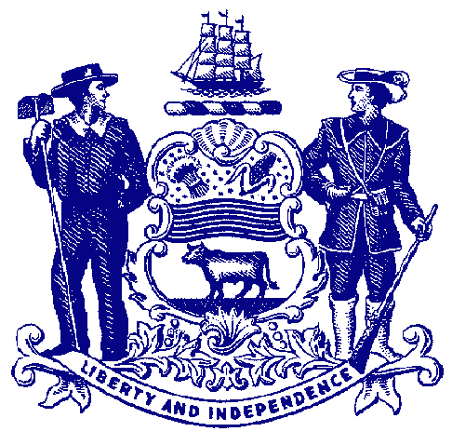



**Council on Greenways & Trails**

December 4, 2015

9:30 am to 12:00

Blue Ball Barn, Alapocas Run State Park

**Agenda**

**Welcome & Introductions**

**Approval of September 25, 2015 Meeting Minutes**

**Trail Updates**

**Trail & Pathway Initiative Projects** – Division staff

Tri-Valley Trail

Rocky Run Bridge, Brandywine Creek SP

Cape Henlopen State Park

Castle Trail

Assawoman Canal Trail – water launch

Auburn Heights Preserve

**Local Projects –** Bob Ehemann

Sussex County

Mill Creek Greenway Trail

Delaware City

**Trail Ranking –** Bob Ehemann

**Brandywine Creek State Park Trail Plan** – David Bartoo

**Recreational Trail Users Update**

Hiking – Wendel Cassel

Mountain Biking – Jim Ireland

Equestrian – Mary Everhart

**New Business**

Extended Trail Hours – Mike Krumrine

**Announcements & Updates**

**Adjourn**