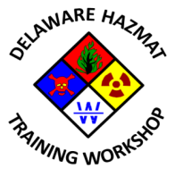

9th Annual State of Delaware Hazardous Materials Training Workshop

Planning Committee Meeting #5
Mill Creek Fire Station 21
Wednesday, December 9, 2015
2:30 PM – 4:30 PM
Agenda

- Call to Order
- Meeting agenda approval
- Previous meeting minutes approval
- Update of Sponsor/Exhibitor commitment/participation
- Review of action items from 11/10/2015 meeting
- 2016 Program Update
- Approval of final draft registration form
- Development of course descriptions and Speaker bios.
- Workshop promotional item(s) funding level and selection
- Any other business
- Next meeting date
- Adjournment

In accordance with 29 Del. C. §10004(e) (2), this Agenda was posted at least seven (7) days in advance of the meeting. This Agenda is subject to change to include the addition or deletion of items, including Executive Sessions, which arise at the time of the Meeting. Agenda items listed may be considered out of sequence.

