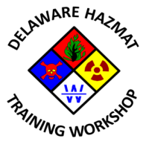

9th Annual State of Delaware Hazardous Materials Training Workshop

Planning Committee Meeting #6
Mill Creek Fire Station 21
Tuesday, January 12, 2016
2:30 PM – 4:30 PM
Agenda

- Call to Order
- Meeting agenda approval
- Previous meeting minutes approval
- Update of Sponsor/Exhibitor commitment/participation
- Review of action items from 12/09/2015 meeting
- 2016 Program Status (sessions, session descriptions and presenter bios)
- Registration launch date status
- Review and approval of shirt for presenters
- Status of sponsorship for Friday – dinner ($2600), Saturday – breakfast ($1000) & lunch ($2000)
- Any other business
- Next meeting date
- Adjournment

In accordance with 29 Del. C. §10004(e) (2), this Agenda was posted at least seven (7) days in advance of the meeting. This Agenda is subject to change to include the addition or deletion of items, including Executive Sessions, which arise at the time of the Meeting. Agenda items listed may be considered out of sequence.

