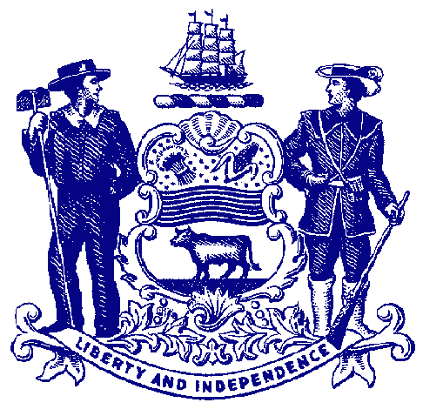



**Council on Greenways & Trails**

March 11, 2016

9:30 am to 12:00

Location: Deerfield - 507 Thompson Station Rd, Newark, DE

**Agenda**

**Welcome & Introductions**

**Approval of December 4, 2015 Meeting Minutes**

**Continuing Business**

* Trail Bond Bill Funds fiscal report – Susan Moerschel
* Trail Ranking – Bob Ehemann

**Recreational Trail Users Update**

* Hiking – Wendel Cassel
* Mountain Biking – Jim Ireland
* Equestrian – Mary Everhart

**Announcements**

* Trail user community meeting – discussion of trail-related issues
* National Trails Day – June 4, 2016
* Council meetings – June 10; October 12

**Tri-Valley Trail Project -** David Bartoo

* Summary
* Field review - the meeting will continue at the Smith Mill Rd Trailhead in Possum Hill Area. Dress for a hike.

**Adjourn**