PUBLIC MEETING
Inspection of Voting Machines
April 5, 2016 at 9:30 a.m. at the Department’s office
100 Enterprise Place, Suite 5, Dover, DE 19904

AGENDA
1. Introductions
2. Overview
3. Discussion about Testing Data
4. View & Inspect Voting Machines for Presidential Primary
5. Public Comments
6. Closing Comments

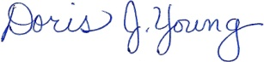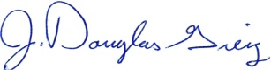
Doris J. Young J. Douglas Greig
Director Deputy Director

This meeting will recess and reconvene if necessary on April 6th at 9:30a.m.

