MINUTES
Logic & Accuracy Test of the Absentee Tabulation System
Wednesday, April 20, 2016 at 10:00 a.m. in the Department of Elections Kent Count Office

Attendees: J. Douglas Greig, Gary Hilderbrand, Alan Nold, Steven L. Smith, Sommer Sturgeon, Doris Young
Meeting Called to Order: 10:03 am by Doris Young
Doris Young stated this is a meeting to Test the Logic & Accuracy of the Absentee Tabulation System in a public forum. The goal is to give the public confidence in the technology and the system.
18 ballots were prepared for testing. These ballots were scanned and reviewed. The test ballots were placed in bag #DD29679247.
No Public was available for comment.
The Department has confidence in the system and has tested it on several occasions prior to the Presidential Primary.
Meeting adjourned at 10:55 am with motion made by J. Douglas Greig, and seconded by Gary Hilderbrand

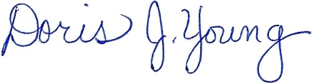
Doris J. Young
County Director

