PUBLIC MEETING
Certification of the Kent County Presidential Primary Results
April 28, 2016 at 12:00 p.m. at the Kent County Office
100 Enterprise Place, Suite 5, Dover, DE 19904
AGENDA
- Call to order
- Introduction
- Overview
- Report on the results of the Presidential Primary
- Objections and/or disputes
- Certification of the results
- Public comments and discussion
- Closing comments
- Adjournment
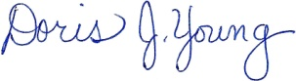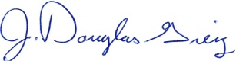
Doris J. Young J. Douglas Greig
Director Deputy Director

