MINUTES

Certification of the Presidential Primary Results for Kent County
April 28, 2016

ATTENDEES: Elaine Manlove, State Election Commissioner, Doris Young, County Director, J. Douglas Greig, Deputy County Director

State Election Commissioner Manlove called the meeting to order at 12:03 p.m.

No one from the public or media was present. County Director Young reported that the County Office staff compared the results reported on the tapes retrieved from the voting machines and the absentee results with the date reported on Election Night. They also verified that 3 Provisional Ballots were not counted. She reported that there were no discrepancies.

State Election Commissioner Manlove adjourned the meeting at 12:10 p.m.

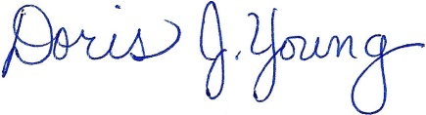

Doris J. Young
County Director

STGP001 v1.1 7/7/2015

