PUBLIC MEETING
Preparation and scanning of Absentee Ballots
April 22, 2016 at 3:00 p.m. at the Department’s office
100 Enterprise Place, Suite 5, Dover, DE 19904

AGENDA
- Call to order
- Introductions
- Overview
- Administering the oath
- Preparing the ballots for tabulation
- Scanning the ballots (will not be tabulated)
- Securing the scanned ballots
- The Office will tabulate the ballots on April 26th at or after 8 p.m.
- Public comments and discussion
- Closing comments
- Adjournment
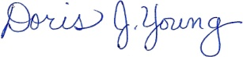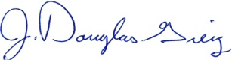
Doris J. Young J. Douglas Greig
Director Deputy Director

This meeting will recess and reconvene as necessary on April 23rd at 3:00 p.m., April 24rd at 3:00 p.m., and April 26th at 1:00 p.m. to prepare and scan.

