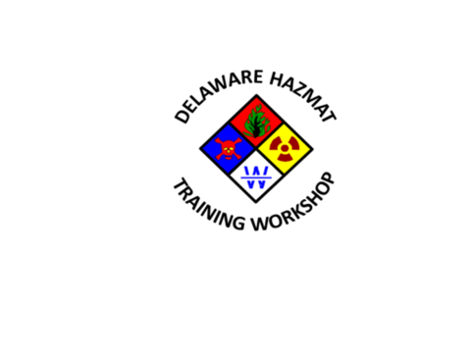
9th Annual State of Delaware Hazardous Materials Training Workshop

Planning Committee Hotwash Meeting
Mill Creek Fire Company, Station 21
Wednesday, April 27th, 2016
2:30 PM -4:30

Meeting Minutes

Voting Members Present: (8)

- Dave Anderson
- Jamie Bethard
- Jerry Brennan
- Ken Cenci
- Mark Dolan
- Dave Irwin
- Rebecca Keyser
- Jake Morente
- Chip Stevenson (Bridge-line)

A quorum (8) was present

Non-voting Members Present: (3)
- Tara Chambers
- Donna Donavan
- Ellen Malenfant

- Call to Order: The meeting was called to order by Chairman Irwin at 2:36 PM.

- Approval of the Agenda:
Chairman Irwin asked for a motion to approve the agenda. Motion to approve agenda by Jake Morente, seconded by Ken Cenci. No discussion on the motion. Motion was unanimously approved.

- Things that went well:

  - Registration, went good
  - Mill Creek Fire Company for handling finances
  - The overall workshop was a huge success with many positive reviews

- Things that could be improved:

  - Fire School staff (LC) and DNREC staff (DD) offered to take workload off DEMA and to better coordinate with new practices.
  - Tracking of dinner participants (separate registration and ticketing)
  - More people at registration table during peak periods; morning rush and pre-dinner.
  - Bottled water for instructors; two bottles in each classroom & cooler in instructors lounge.
  - Course review sheets, pre-list course name & instructor

- Any new items that could improve the overall process:

  - Bring Hazmat 30 (NCC Decon rig) for display and maybe Kent and Sussex Units?

- Review & discuss session evaluations:

  - Reviewed several pages of evaluation quotes, all very positive
  - Vast majority was very pleased with workshop, courses and instructors

- Discuss attendance:
  - Jerry Brennan reported 227 attendees on Friday, April 1st and 218 attendees for Saturday, April 2nd. 135 people for Friday evenings dinner and presentation.

- Income and expenses:
Mark Dolan provided a detailed spreadsheet from Mill Creek Fire Company on all income and expenses for the workshop. Waiting on a few outstanding pledges totaling $3000.
Income: $18,670
Expenses: $17,247
Balance: $1,423

- Vote to conduct a 10th Annual Workshop
Motion by Mark Dolan, seconded by Jake Morente, no discussion. Unanimously approved. Chairman Irwin will make and workshop presentation to SERC at the June 8th, 2016 meeting and ask for approval for the 10th annual in 2017.

- Develop a vendor source list:
The committee updated a spreadsheet with vendors, previous items, unit and bulk costs, etc. This will help planning if a 10th annual training workshop is approved.

- Review and update task list:
The committee updated a spreadsheet with tasks and items for consideration for another training workshop.

- Any other business:

  - Jerry Brennan reported that next year’s available dates at the Fire School (always the weekend after Easter), Friday, April 21 and Saturday, April 22^{nd,} 2017

  - Chairman Irwin will send out an email if the SERC approves a 10th annual hazmat training workshop for the 1st committee planning meeting in mid-August. Mark Dolan will request the training room at Mill Creek Fire Company, Station #21 2:30-4:30pm

- Adjournment: Motion to adjourn by Mark Dolan, seconded by Jerry Brennan. Meeting adjourned at 4:41 PM.

Recorded and submitted by Jake Morente

