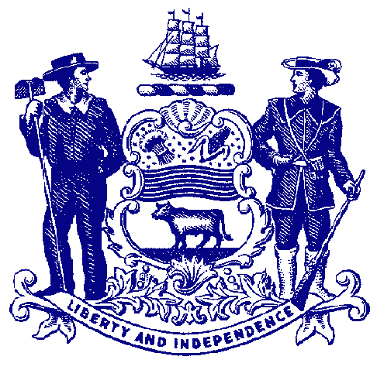



**Council on Greenways & Trails**

June 10, 2016

9:30 am to 12:00

Location: Dover Public Library

35 E. Loockerman Street, Dover, DE

**Agenda**

**Welcome & Introductions**

**Approval of March 11, 2015 Meeting Minutes**

**Trail Updates**

* Bayshore projects – Denise Husband
* Tri-Valley Trail Project – Matt Chesser or Ray Bivens
* Auburn Valley Preserve/NVF – Matt Chesser
* Killens Pond State Park Trail Plan – David Bartoo
* Assawoman Canal Phase 2 Feasibility update – Susan Moerschel
* Georgetown-Lewes-Cape – Susan Moerschel

**Report**

* Trail Bond Bill Funds fiscal report – Susan Moerschel
* Trail Use Counts – David Bartoo

**Recreational Trail Users Update**

* Hiking – Gary Kirk
* Equestrian - Mary Everhart
* Mountain Biking – Jim Ireland

**New Business**

* Dedication to Wendel Cassel – Gary Kirk

**Announcements**

* Council meeting – October 12

**Adjourn**