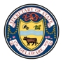

Public Hearing for Review of Agency Regulations

Tuesday, August 2, 2016
12:30 p.m.
Carvel State Building
Secretary of State’s Office, 4th Floor Conference Room
820 N. French Street
Wilmington, DE 19801

Agenda
- Introduction by Agency Official
- Accept comment submissions – both written and oral
- Closing remarks by Agency Official

