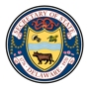

Public Hearing for Review of Agency Regulations

Wednesday, August 3, 2016
12:30 p.m.
John G. Townsend Building
Secretary of State 1st floor Conference Room
401 Federal Street
Dover, DE 19901

Agenda
- Introduction by Agency Official
- Accept comment submissions – both written and oral
- Closing remarks by Agency Official

