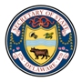

Public Hearing for Review of Agency Regulations

Thursday, August 4, 2016
12:30 p.m.
Georgetown Public Library
Public Meeting Room
123 West Pine Street
Georgetown, DE 19947

Agenda
- Introduction by Agency Official
- Accept comment submissions – both written and oral
- Closing remarks by Agency Official

