MINUTES
Logic & Accuracy Test of the Absentee Tabulation System
Wednesday, September 7, 2016 at 10:00 a.m. in the Department of Elections Kent Count Office

Attendees: Ralph Artigliere, Chelsea Barnett, Garry Glanden, J. Douglas Greig, Carolyn Martin-Pettaway, John Moller, Alan Nold, Steven L. Smith, Sommer Sturgeon, Doris Young
Meeting Called to Order: 10:05 am by Doris Young
Doris Young stated this is a meeting to Test the Logic & Accuracy of the Absentee Tabulation System in a public forum. The goal is to give the public confidence in the technology and the system.
Carolyn Martin-Pettaway from Sherry Dorsey Walker’s Campaign and Chelsea Barnett from Colin Bonini’s Campaign assisted with testing ballots and felt confident in the Absentee Scanning System.
155 ballots were prepared for testing. These ballots were scanned and reviewed. The test ballots were placed in bag #DD36630893.
No comments from Public or Representatives.
The Department has confidence in the system and has tested it on several occasions prior to the State Primary.
Meeting adjourned at 11:45 am with motion made by J. Douglas Greig, and seconded by Steven L. Smith.

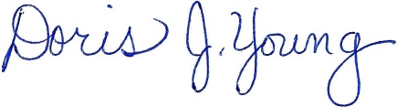
Doris J. Young
County Director

