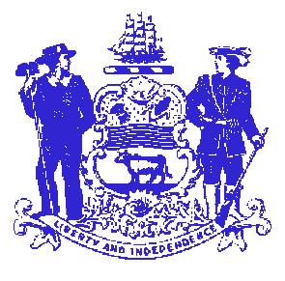

Telephone: (302) 577-5030
Fax: (302) 577-3440
STATE OF DELAWARE

EXECUTIVE DEPARTMENT
CRIMINAL JUSTICE COUNCIL
STATE OFFICE BUILDING – 10th FLOOR
820 FRENCH STREET
WILMINGTON, DELAWARE 19801

SAKI Multi-Disciplinary Group
October 13, 2016
10:00AM-12:00PM

House Majority Hearing Room
2nd Floor
Legislative Hall
Dover, DE 19901

- Welcome and Introductions

- Background on the Criminal Justice Council’s SAKI Grant
- Goals & Objectives

- Identify Chairperson

- Establish Subcommittees

- Other Business

Public comment may be time limited, as set by the Chair.

Pursuant to DE Code: Title 29 § 10004 (e)(2), the Committee shall pre-announce all Executive Sessions; however, such agenda shall be subject to change to include additional items including Executive Sessions which may arise at the time of the Committee’s meeting.

