PUBLIC MEETING
Recount of the Primary Election Absentee Ballots
September 14, 2016 10 a.m. in the Kent County Office
100 Enterprise Place, Suite 5, Dover, DE 19904

Note: Delaware code, Title 15, §5702 provides for automatic recount of absentee ballots under certain conditions. If required, the Department will recount the absentee ballots of the affected race/s. If not required, the Department will cancel the meeting.

AGENDA
- Call to order
- Introduction
- Overview
- Recount of Absentee Ballots
- Report of the results of the recount
- Public comments and discussion
- Closing comments
- Adjournment
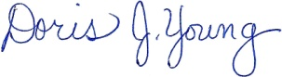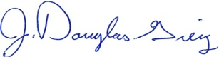
Doris J. Young J. Douglas Greig
Director Deputy Director

