PUBLIC MEETING
Inspection of Voting Machines for Kent County
October 18, 2016 at 9:00 a.m. at the Department’s Kent County office
100 Enterprise Place, Suite 5, Dover, DE 19904

AGENDA
1. Introductions
2. Overview
3. Discussion about Testing Data
4. View & Inspect Voting Machines for General Election
5. Public Comments
6. Closing Comments

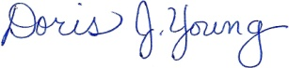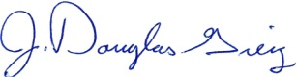
Doris J. Young J. Douglas Greig
Director Deputy Director

This meeting will recess and reconvene if necessary on October 19th at 9:30a.m.

