PUBLIC MEETING
Logic & Accuracy Test for the Kent County Office
Absentee Tabulation System for the General Election
Pursuant to Delaware Code Title 15 §5523
November 1, 2016 at 10:00 a.m. at the Department’s Kent County Office
100 Enterprise Place, Suite 5, Dover, DE 19904
AGENDA
- Call to order
- Introduction
- Overview
- Inspection of the equipment
- Voting the ballots
- Tabulation of the ballots
- Verifying the results
- Securing the test ballots, results, etc.
- Public comment and discussion
- Closing comments
- Adjournment
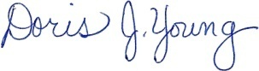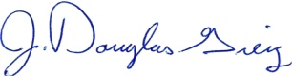
Doris J. Young J. Douglas Greig
Director Deputy Director

