

Cannon Building | STATE OF DELAWARE | Telephone: (302) 744-4500
861 Silver Lake Blvd., Suite 203 | DEPARTMENT OF STATE | Fax: (302) 739-2711
Dover, Delaware 19904-2467 |  | Website: www.dpr.delaware.gov
 | DIVISION OF PROFESSIONAL REGULATION

PUBLIC MEETING MINUTES: Board of Professional Land Surveyors

MEETING DATE AND TIME: Thursday, February 16, 2006 at 9:30 a.m.

PLACE: 861 Silver Lake Boulevard, Dover, Delaware
Conference Room A, Second floor of the Cannon Building

MINUTES APPROVED: Approved as Amended

MEMBERS PRESENT

Elton Murray, Chairman, Professional Member, Presiding
Roy B. Adams III, Vice-Chairman, Professional Member

Lena M. Corder, Secretary, Public Member
Amos W. Aiken, Public Member

Michael Szymanski, Professional Member
Victor Kennedy, Public Member

DIVISION STAFF/DEPUTY ATTORNEY GENERAL PRESENT

Frederick H. Schranck, Deputy Attorney General
Kay Warren, Deputy Director, Division of Professional Regulation
Peggy A. Foreit, Administrative Specialist II
Katie Rochester, Administrative Specialist II

MEMBERS ABSENT
Russel Dolbeare, Professional Member

CALL TO ORDER

Mr. Murray called the meeting to order at 9:35 a.m.

REVIEW OF MINUTES

The board reviewed the minutes of the January 19, 2006, Meeting. Mr. Murray made a motion to approve the minutes, seconded by Mr. Aiken . The motion was unanimously carried.

UNFINISHED BUSINESS

Introduction of New Board Member
Mr. Murray introduced Mr. Michael T. Szymanski, the newly appointed Professional Member, to the board. Mr. Szymanski is replacing Mr. Early whose term of service ended in February 2006.

NEW BUSINESS

Review of Land Surveyor Applications

The Board reviewed the applications of William M. Ewald, Sr. and Donald S. Finch for licensure. A motion was made by Mr. Kemp and seconded by Mr. Murray to table these applications until the next meeting because required documentation was not submitted to complete the application process. The Board unanimously approved the motion.

The Board reviewed the application of Mr. Troy Adams. A motion was made Mr. Kemp and seconded by Mr. Kennedy to deny the application for license because Mr. Adams does not meet the minimum experience requirement for licensure as a Professional Land Surveyor. The Board unanimously approved the motion.

The Board reviewed the application of Mr. Donald Lance. A motion was made by Mr. Kemp and seconded by Mr. Murray to approve the applicant to sit for the Fundamentals of Surveying, Principles and Practices of Surveying and the State Drainage Examination in April, 2006. The Board unanimously approved the motion.

Review of Continuing Education Courses

The board received a request from Lorman Education for the approval of three courses for personal development hours. Mr. Kemp made a motion, seconded by Mr. Murray to approve the courses by Lorman Education for the listed below Personal Development Hours (PDH’s). The Board unanimously approved.

Lorman Education
”Zoning and Land Use” Seminar – 5/18/06 – 6.5 PDH’s
Lorman Education
“Property through Eminent Domain: What You Need to
Know in Delaware” – 3/16/06 – 6/0 PDH’s
Lorman Education
“Land Use Law: Current Issues in Subdivision, Annexation
And Zoning: - 5/23/2006 – 6.0 PDH’s

The board received a request from PESI (Professional Education Systems Institute), ACSM (American Congress for Survey Management) and DTCC (Delaware Technical Community College for the approval of courses for Personal Development Hours. Mr. Kemp made a motion to approve the courses as listed below for Personal Development Hours, seconded by Mr. Aiken. The Board unanimously approved the motion.

PESI
“Emerging Trends in Surveying and Real Property Law” – 15 PDH’s
ACSM
2006 Annual Conference and Technology Exhibitions –
ALTA/ACSM Land Title Surveys – 8 PDH’s
Practical GIS for Everyday Surveying – 8 PDH’s
Geographic Information Systems for Engineers, Surveyors, and Municipal Managers 8 PDH’s
Easements as Seen Thru Case Law – 8 PDH’s
Geodetic and Tidal Vertical Datum – 8 PDH’s
Documenting the File-How and Why of File Recordation and Documentation –
4 PDH’s
Higher Order Surveying in the Southeastern US – 4 PDH’s
Evidence, Exhibits and Testimony: Boundaries and Beyond – 8 PDH’s
RTK GPS Workshop and/or Data Collector Workshop – 8 PDH’s
GPS Vector Processing and Concepts as Implemented in the PAGES Software Suite 8 PDH’s
Large Scale Topographic Mapping for Surveyors – 8 PDH’s
Justice Cooley of Michigan Meets Justice Lumpkin of Georgia – 8 PDH’s
Making the Most of Your Total Station – 4 PDH’s
The Surveyor’s Role in Flood Studies – 4 PDH’s
Situational Ethics for Land Surveyors – 4 PDH’s
Public Data, Public Access, Privacy, and Security: U.S. Law and Policy – 8 PDH’s
The Rectangular Land System: Subdivision of the Public Lands – 8 PDH’s
Introduction to Using CORS & OPUS – 4 PDH’s
The Quasi-Judicial Functions of the Land Surveyor – 4 PDH’s
Asset Management: Planning, Strategy, and Implementation – 8 PDH’s
Running a Successful Surveying Business (the surveying is the easy part) – 8 PDH’s
Hydrographic Surveying – 8 PDH’s
GPS, Geodesy, and the Ghost in the Machine: A Modern Surveying and Mapping Workshop – 8 PDH’s
Organize your computer files (emphasis on CAD files) – 4 PDH’s
Map Projection Fundamentals – 4 PDH’s
GPS-Derived Heights Part I, Development and Description of NGS Guidelines
- 4 PDH’s
The marketable Record Title Act (MRTA) – 4 PDH’s
GPS-Derived Heights Part II, Development and Description of NGS Guidelines
- 4 PDH’s
Orthophotography and Its Application – 4 PDH’s
“CSI” (Corner Site Investigation) – Forensics of Surveying – 4 PDH’s
This Little Piggy Went to the Market, This Little Piggy Stayed Home – 4 PDH’s
The Expert Witness – 4 PDH’s
Understanding Errors in Measurements – 4 PDH’s
So, You’ve Discovered a Conflict – Now What? – 8 PDH’s
Weighted Coordinate Transformations and Their Applications in SPCS and Boundary Surveying – 4 PDH’s
Geomapping for data visualization – 4 PDH’s
DTCC
OSHA 10-Hour Construction Safety Outreach Program – 10 PDH’s

Wall Certificates

Peggy Foreit provided the wall certificates for signature to the board members.

Board Contact Assignment for Complaint Number 05-01-06

Mr. Szymanski was assigned as the board member contact for Complaint Number 05-01-06.

Other Business Before the Board

Mr. Kemp raised the issue that when a board member is assigned a complaint they should be contacted while the investigation is in process and not at the point the case is ready for closure. Mr. Kemp further stated that the board contact is able to provide vital information that may change the questions that are posed to the various parties concerning the complaint. Mr. Kemp stated this will save the investigator, the board contact, and various parties valuable time and may change the basis for the outcome of the complaint.

It was requested by Mr. Kemp to begin the board meetings at 8:30 a.m. versus 9:30 am. A motion was made by Mr. Kemp and seconded by Mr. Murray to approve the time change for the meeting. The board unanimously approved the motion.

Mr. Szymanski stated that he would like to compose a letter concerning Plats vs. Boundary Surveys. Mr. Szymanski will provide the letter to the board administrative specialist who present the letter at the next meeting for review by all members. Once the letter is complete it will be signed by Mr. Murray and provided to the county administrators.

Public Comment

There was no public comment at this meeting.

Next Scheduled Meeting

The next meeting will be held on Thursday, March 16, 2006 at 8:30 a.m. in Conference Room A, second floor of the Cannon Building, 861 Silver Lake Boulevard, Dover, Delaware.

Adjournment

There being no further business, Mr. Kennedy motioned and seconded by Mr. Aiken to adjourn the meeting. The motion was unanimously carried. The meeting adjourned at 11:30 a.m.

Respectfully submitted,

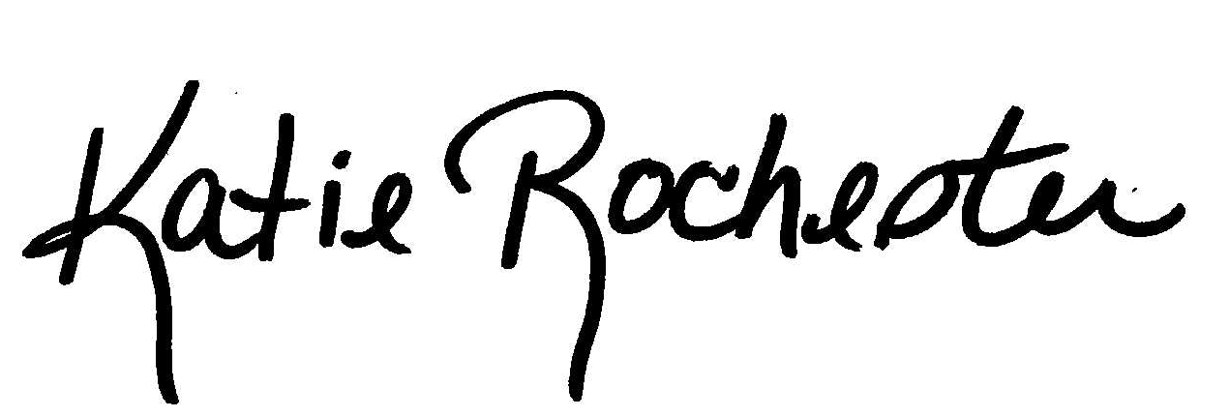

Katie Rochester
Administrative Specialist II

