

Cannon Building | STATE OF DELAWARE | Telephone: (302) 744-4500
861 Silver Lake Blvd., Suite 203 | DEPARTMENT OF STATE | Fax: (302) 739-2711
Dover, Delaware 19904-2467 |  | Website: www.dpr.delaware.gov
 | DIVISION OF PROFESSIONAL REGULATION

PUBLIC MEETING MINUTES: Board of Professional Land Surveyors

MEETING DATE AND TIME: Thursday, March 16, 2006 at 8:30 a.m.

PLACE: 861 Silver Lake Boulevard, Dover, Delaware
Conference Room A, Second floor of the Cannon Building

MINUTES APPROVED: Approved as Amended 04/20/06

MEMBERS PRESENT

Elton Murray, Chairman, Professional Member, Presiding
Roy B. Adams Kemp III, Vice-Chairman, Professional Member

Lena M. Corder, Secretary, Public Member
Amos W. Aiken, Public Member

Michael Szymanski, Professional Member
Victor Kennedy, Public Member
Russel Dolbeare, Professional Member

DIVISION STAFF/DEPUTY ATTORNEY GENERAL PRESENT

Abby Adams, Deputy Attorney General
James Collins, Director, Division of Professional Regulation
Peggy A. Foreit, Administrative Specialist II
Katie Rochester, Administrative Specialist II

MEMBERS ABSENT
None

CALL TO ORDER

Mr. Murray called the meeting to order at 8:30 a.m.

REVIEW OF MINUTES

The board reviewed the minutes of the February 16, 2006 Meeting with amendments from Mr. Kennedy. Mr. Aiken made a motion to approve the minutes, seconded by Ms. Corder. The motion was unanimously carried.

UNFINISHED BUSINESS

Mr. Murray, Mr. Kemp and Mr. Aiken volunteered to represent new House Bill for court venue change should it be necessary. The motion was made by Mr. Szymanski to approve and seconded by Mr. Dolbeare. The motion was carried unanimously.

Review of Land Surveyor Applications

The Board reviewed the application of William M. Ewald, Sr. for licensure. A motion was made by Mr. Dolbeare and seconded by Mr. Aiken to table the application until the next meeting due to the fact that the required documentation was not submitted to complete the application process. The Board unanimously approved the motion.

The Board reviewed the application of Donald K. Finch for licensure. A motion was made by Mr. Kemp and seconded by Mr. Dolbeare to table the application until the next meeting due to the fact that the required documentation was not submitted to complete the application process. The Board unanimously approved the motion.

The Board reviewed the application of Alan O. Kent for licensure. A motion was made by Mr. Murray and seconded by Mr. Kemp to table the application until the next meeting due to the fact that the required documentation was not submitted to complete the application process. The Board unanimously approved the motion.

The Board reviewed the application of Troy Lamont Adams for licensure. A motion was made by Mr. Kemp and seconded by Mr. Szymanski to propose to deny the application due to the fact that the required documentation was not submitted to complete the application process. The Board unanimously approved the motion.

The Board reviewed the application of John K. Pierce for licensure. A motion was made by Mr. Murray and seconded by Mr. Kemp to approve the application and to sit for the State Drainage exam on April 21, 2006. The Board unanimously approved the motion.

The Board reviewed the application of C. Wayne Sweikert for licensure. A motion was made by Mr. Szymanski and seconded by Mr. Kennedy to propose to deny the application due to the fact that the applicant has violated a stipulation of the rules and regulations. The Board unanimously approved the motion.

The Board reviewed the application of Doug Williams for licensure. A motion was made by Mr. Dolbeare and seconded by Mr. Aiken to approve the application and to sit for the State Drainage exam on April 21, 2006. The Board unanimously approved the motion.

The Board reviewed the application of Edward Patalano for licensure. A motion was made by Mr. Szymanski and seconded by Mr. Kemp to propose to deny the application due to the fact that the required documentation was not submitted to complete the application process. The Board unanimously approved the motion.

Ms. Foreit brought up the subject of the state drainage exam and reviewing the questions. She said that she has received several complaints from recent applicants that have stated that they believe that some of the answers that they got wrong were due to the fact that the questions were outdated and not what they were taught. Mr. Kemp and Mr. Szymanski volunteered to review the exam.

NEW BUSINESS

Mr. Szymanski presented a drafted letter to the Board for their review concerning Plats and Monument placement. Mr. Szymanski drafted the letter which he feels should be sent to all municipalities and county governments to ensure that they are aware of the Minimum Technical Standards and that recorded plats are in compliance with said Standards. Mr. Dolbeare motioned that the letter be tabled until the next meeting so that Mr. Schrank would have time to review it and discuss with the Board. The motion was seconded by Mr. Aiken. The Board unanimously approved the motion.

The Board reviewed Rules & Regulations for 10.0 and 16.0. There is some conflicting information concerning Professional Development Hours and time to renew a license. The Board agreed that this needs to be revised prior to next year’s renewal. The motion was made by Mr. Kemp to table this until the next meeting to review with Mr. Schrank. The motion was seconded by Mr. Dolbeare. The Board unanimously approved the motion.

A proposal for 2011 Annual Meeting was brought before the board to discuss whether they would be interested in hosting the meeting. No decision was made.

The NSPS Conference is coming in April and Ms. Foreit asked the Board if anyone was interested in attending the conference. No one on the Board was planning on attending.

Review of Continuing Education Courses

The board received a request from PA. Society of Land Surveyors, for the approval of: “National Flood Insurance Program for Design for Professional and Community Officials”, for seven personal development hours. Mr. Kemp made a motion, seconded by Mr. Szymanski to approve the courses by PA. Society of Land Surveyors for 7 PDH’s. The Board unanimously approved.

Other Business Before the Board (for discussion only)
The discussion of Emeritus status for Mike Early was brought up and requested to be placed on the agenda for the next meeting.

Katie Rochester questioned the board as to whether Geography could be an approved curriculum for licensure through education. Mr. Dolbeare answered that he believed that it was and for the licensee to send in his application for review.

Mr. Szymanski requested to be contacted by License Investigator handling case #05-01-06.

Mr. Szymanski stated that the application process is antiquated and that it should be revisited. He also stated that he wants to address the possibility of requiring a Surveyor in Training program for the state of Delaware. He said that this program is offered in many other states. He also stated that the board needs to review the educational requirements for licensure.

Public Comment

There was no public comment at this meeting.

Next Scheduled Meeting

The next meeting will be held on Thursday, April 20, 2006 at 8:30 a.m. in Conference Room A, second floor of the Cannon Building, 861 Silver Lake Boulevard, Dover, Delaware.

Adjournment

There being no further business, Mr. Dolbeare motioned and seconded by Mr. Kemp to adjourn the meeting. The motion was unanimously carried. The meeting adjourned at 11:40 a.m.

Respectfully submitted,

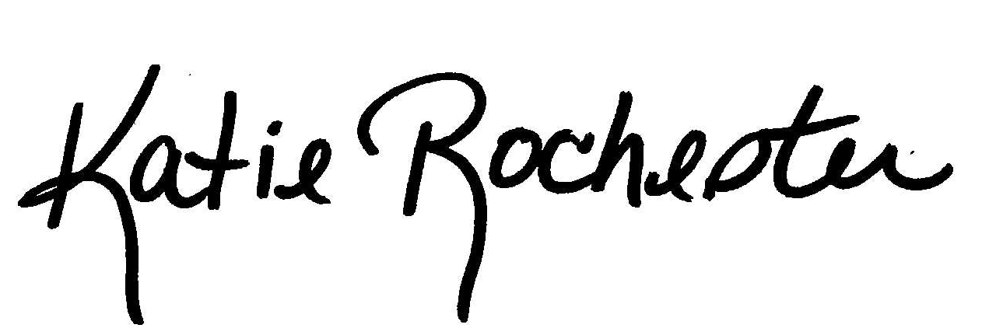

Katie Rochester
Administrative Specialist II

