

Cannon Building | STATE OF DELAWARE | Telephone: (302) 744-4500
861 Silver Lake Blvd., Suite 203 | DEPARTMENT OF STATE | Fax: (302) 739-2711
Dover, Delaware 19904-2467 |  | Website: www.dpr.delaware.gov
 | DIVISION OF PROFESSIONAL REGULATION

PUBLIC MEETING MINUTES: Board of Professional Land Surveyors

MEETING DATE AND TIME: Thursday, May 18, 2006 at 8:30 a.m.

PLACE: 861 Silver Lake Boulevard, Dover, Delaware
Conference Room A, Second floor of the Cannon Building

MINUTES APPROVED: Approved 06/15/06

MEMBERS PRESENT

Roy B. Kemp III, Vice-Chairman, Professional Member

Amos W. Aiken, Public Member

Michael Szymanski, Professional Member
Victor Kennedy, Secretary, Public Member

DIVISION STAFF/DEPUTY ATTORNEY GENERAL PRESENT

Frederick Schrank, Deputy Attorney General
Kay Warren, Deputy Director, Division of Professional Regulation

Katie Rochester, Administrative Specialist

MEMBERS ABSENT
Theodore Ressler, Public Member
Elton Murray, Chairman, Professional Member
Russel Dolbeare, Professional Member

CALL TO ORDER

Mr. Kemp called the meeting to order at 8:35 a.m.

REVIEW OF MINUTES

The board reviewed the minutes of the April 20, 2006 Meeting. A change in wording was made to the section “Other Business”. Mr. Aiken made a motion to approve the meeting minutes with the amended changes, seconded by Mr. Kennedy. The motion was unanimously carried.

UNFINISHED BUSINESS

The Board was presented with copies of letters from James Collins to Senator McBride and Representative Hudson for the PLS House Bill that changes the court venue from Superior Court to Justice of the Peace Court. Ms. Warren explained that the letters were sent by
James Collins, DPR Director, in order to obtain sponsorship of the bill by either a House Representative or a Senator. Sponsorship is necessary in order to get the bill introduced and passed during this session.

The board received a request from Delaware Technical & Community College – Owens Campus for the approval of: “Introduction to Autodesk Land Desktop (LLD)” for 21 PDH’s and “Introduction to Mapping and GIS” for 7 PDH’s. The college explained that these are ongoing courses and that they will request approval for these courses every two years. Upon that guarantee the board approved the courses. Mr. Kemp made a motion and seconded by
Mr. Szymanski. The Board unanimously approved.

NEW BUSINESS

Kay Warren, Deputy Director for the Division of Professional Regulation, gave a Power Point Presentation on the Voluntary Treatment Option Program (VTO) that is offered for many licensees. The VTO Program gives licensees the opportunity to get assistance if they have an addiction problem prior to that problem affecting their work. Several questions were posed by the board and answered by Ms. Warren. The program requires a board member to be a coordinator for the program. Mr. Szymanski volunteered to be the coordinator. The Board agreed.

Review of State Drainage Results from the April 2006 Exam
The Board reviewed the results and commented that with only a 35% passing rate they may need to review the exam in an effort to see if there are any major changes that would prevent one from passing the exam.

Review of Applications for Licensure
The Board reviewed and approved the following applicants for licensure: Timothy Cawood, Roger Fields, Paul Moody, and Charles Ruzicka. The motion was made by Mr. Szymanski and seconded by Mr. Aiken. The Board unanimously approved the motion.

Review of Application for Exam
The Board reviewed the application of David Shumate for licensure. A motion was made by
Mr. Kemp and seconded by Mr. Kennedy to table the application of Mr. Shumate. Mr. Shumate did not supply the required documentation to complete the application process. The Board unanimously approved the motion.

Review of Continuing Education Courses

The Board reviewed and approved the following courses for the designated PDH’s: Lorman Business Center, Inc. Surveys and Subdivision Plans – 6.0 PDHs and Land Development – 6.0 PDHs. The motion was made by Mr. Szymanski and seconded by Mr. Aiken. The Board unanimously approved the motion.

The Board reviewed and tabled the following course: Lorman Business Center, Inc. The Turbulent State of Federal Wetlands Jurisdiction – 1.5 PDHs, due to the fact that it is a teleconference and the Board required more information about the process. The motion was made by Mr. Szymanski and seconded by Mr. Aiken. The Board unanimously approved the motion.

The Board denied the following courses: Lorman Business Center, Inc., Developing a Property Management Plan – 1.5 PDH’s and Inverse Condemnation Law – 1.5 PDH’s, due to the fact that they had nothing to do with Surveying. The motion was made by Mr. Szymanski to deny the courses for PDH Credit and seconded by Mr. Aiken. The Board unanimously approved the motion.

Other Business Before the Board (for discussion only)
Mr. Szymanski wanted to discuss the subject of the Land Surveyor In-Training Project that he recommends the Board should adopt. He explained that he has been doing some research and upon the suggestion of Deputy Attorney Schrank he reviewed the model law from NCEES.
Mr. Szymanski provided copies of the model law with highlighted sections to the board for their review. Mr. Schrank stated that the Board should move forward with drafting legislation and he explained that it is a “model” to be used as a guideline but doesn’t required strict adherence.

Public Comment

There was no public comment at this meeting.

Next Scheduled Meeting

The next meeting will be held on Thursday, June 15, 2006 at 8:30 a.m. in Conference Room A, second floor of the Cannon Building, 861 Silver Lake Boulevard, Dover, Delaware.

Adjournment

There being no further business, Mr. Kemp motioned and seconded by Mr. Aiken to adjourn the meeting. The motion was unanimously carried. The meeting adjourned at 10:45 a.m.

Respectfully submitted,

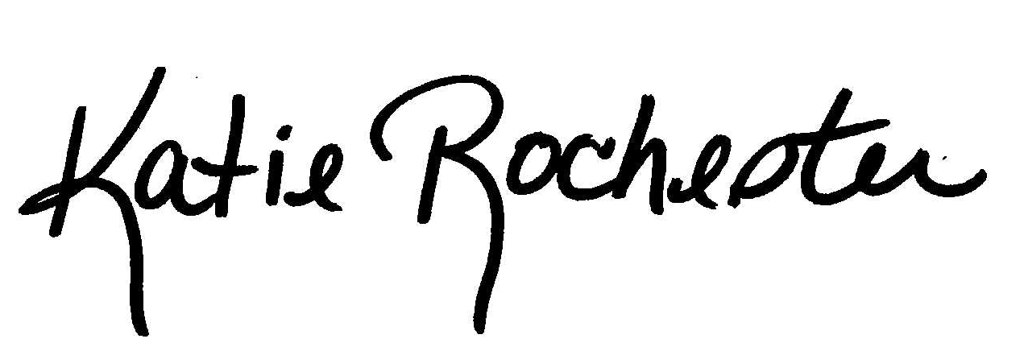

Katie Rochester
Administrative Specialist II

